An Integrated Method for Dairy Cow Pain Detection Combining Grimace Scale and Semantic Segmentation

Abstract
The detection of cow pain is an important issue in the field of veterinary medicine. Traditional methods for detecting cow pain are divided into subjective and objective methods. Although objective methods are relatively accurate, they lack real-time performance. While subjective methods can achieve real-time detection, they require a large amount of manual labor and are easily affected by the subjectivity of veterinarians and the environment. To address the above issues, this paper proposes a method for detecting cow pain that combines a semantic segmentation algorithm with a cow facial pain scale, referred to as the Pain-Score method. The Pain-Score method first uses a semantic segmentation algorithm to achieve fine segmentation of the cow's face, aiming to obtain the parts of the cow's face required by the cow facial pain scale. Secondly, a deep learning classifier is used to score each part of the cow's face, and the scores of each part are added together to obtain the total score. Finally, by combining the total score with a pre-set pain threshold, accurate detection of cow pain can be achieved. Experiments show that the Pain-Score method can achieve good cow pain detection. On our cow pain dataset, the F1-score, AUC, Recall, and G-mean of the Pain-Score method reach 0.9408, 0.9318, 0.9173, and 0.9599 respectively.
Keywords: Semantic Segmentation，Pain Detection，Dairy Cows，Pain Scale，Deep learning
- Introduction
Dairy cows pain is a negative emotional experience for dairy cows, and it is often related to organ damage in dairy cows (MERSKEY, 1979). Methods for detecting dairy cows pain are divided into two types, subjective methods and objective methods (O’Callaghan et al., 2003). Objective methods require collecting relevant physiological data from cows first(Tschoner, 2021), Such as cortisol, endorphin and heart rate(Zoltick et al., 2024). Then, the collected data need to be analyzed to further determine whether the dairy cows are in pain. This results in the fact that objective methods usually lack real-time performance and are unable to achieve detection and intervention within a short period of time after the dairy cows experience pain (Higaki et al., 2024). Subjective methods involve establishing evaluation criteria, where veterinarians assess the pain level of dairy cows based on their own experience and observation of the animals. Such methods are highly dependent on veterinarians' experiences (Tschoner et al., 2024). Subjective methods require veterinarians to make corresponding judgments after carefully observing each dairy cow, a process that is time-consuming and tedious. Additionally, veterinarians’ observations of dairy cows are easily influenced by environmental factors. The most common subjective approach currently used is for veterinarians to determine whether dairy cows are in pain through pain scales. A pain scale records the scoring criteria for pain responses in dairy cows (or specific parts of their bodies), enabling veterinarians to assign corresponding pain scores based on the scale and further determine the pain of dairy cows status through these scores.Commonly used pain scales for dairy cows include the Dairy Cow Behavioral Pain Scale (Gleerup et al., 2017)and the Dairy Cow Grimace Pain Scale(Farghal et al., 2024). Compared with the pain-related behaviors of dairy cows, their facial states when in pain are simpler and easier to observe.(Gleerup et al., 2015). Therefore, this paper selects the dairy cow facial pain scale for pain detection. However, with the development of the dairy industry, subjective methods based on pain scales are difficult to be widely applied in large-scale farms. Manual fine observation of all dairy cows is impractical; under extreme weather conditions, it is challenging for humans to fully observe dairy cows; additionally, differences in pain judgment among veterinarians tend to increase as farm scale expands. Combining semantic segmentation algorithms with subjective methods for dairy cow pain detection represents a viable new strategy. However, no existing research has deeply explored the application of semantic segmentation algorithms in this specific context.
Therefore, this paper proposes the Pain-Score method for dairy cow pain detection, which integrates semantic segmentation algorithms and the dairy cow facial pain scale. First, the method uses a semantic segmentation algorithm to achieve fine-grained segmentation of the dairy cow’s face, aiming to isolate the facial regions required by the facial pain scale: ears, eyes, cheeks, mouth, nose, and the muscles above the eyes. After the semantic segmentation model extracts these facial parts, Pain-Score employs deep learning classifiers to score each region based on the dairy cow facial pain scale—different deep classifiers are used for scoring distinct facial components. Finally, the scores of all facial parts are summed to obtain the total pain score for the dairy cow. By combining this total score with a pre-defined pain threshold, the method enables pain detection.The semantic segmentation algorithm in Pain-Score is based on DeeplabV3+, one of the most popular semantic segmentation algorithms. To address issues in the original DeeplabV3+ such as unbalanced deep-shallow feature integration and poor image reconstruction capability, this study introduces the Efficient Channel Attention (ECA), Feature Pyramid Network (FPN), and Single Shot Context (SSH) modules for optimization, naming the improved algorithm Pain-Deeplab. The Pain-Score method leverages high-performance semantic segmentation and the authoritative dairy cow facial pain scale to achieve fine facial segmentation and accurate regional scoring. These scores are continuously updated in the model over time, ultimately enabling real-time and precise detection of pain in dairy cows.
The Pain-Score method demonstrates the potential of deep learning in advancing precision agriculture and automated farm management. Overall, the contributions of this paper are as follows:
- We propose a dairy cow pain detection method based on semantic segmentation and the dairy cow facial pain scale, namely Pain-Score. Pain-Score achieves fine-grained segmentation of dairy cow faces and accurate scoring of individual facial components, enabling real-time and precise detection of pain in dairy cows.
- We develop an improved semantic segmentation method based on DeepLabV3+, termed Pain-Deeplab. By integrating the Efficient Channel Attention (ECA), Feature Pyramid Network (FPN), and Single Shot Context (SSH) modules, Pain-Deeplab enhances the performance of the original DeepLabV3+ algorithm, achieving detailed segmentation of dairy cow faces.
- We introduce a framework that combines deep learning with subjective pain detection methods for dairy cows. This approach can be applied to other dairy cow pain scales, enabling real-time and accurate pain detection in dairy cows.
- Related Works
Since subjective dairy cow pain detection was first proposed, subjective methods have been increasingly used to detect pain in dairy cows(O’Callaghan et al., 2003). Pain scales are the most commonly used subjective methods. In recent years, Farghal et al.(Farghal et al., 2024)proposed the dairy cow facial pain scale, which includes six indicators(eyes, nostrils, mouth, muscles above the eyes, face, and ears). By focusing its scoring criteria on the facial regions of dairy cows, this scale is more conducive to integration with computer vision algorithms. The dairy cow facial pain scale is shown in Figure 1.
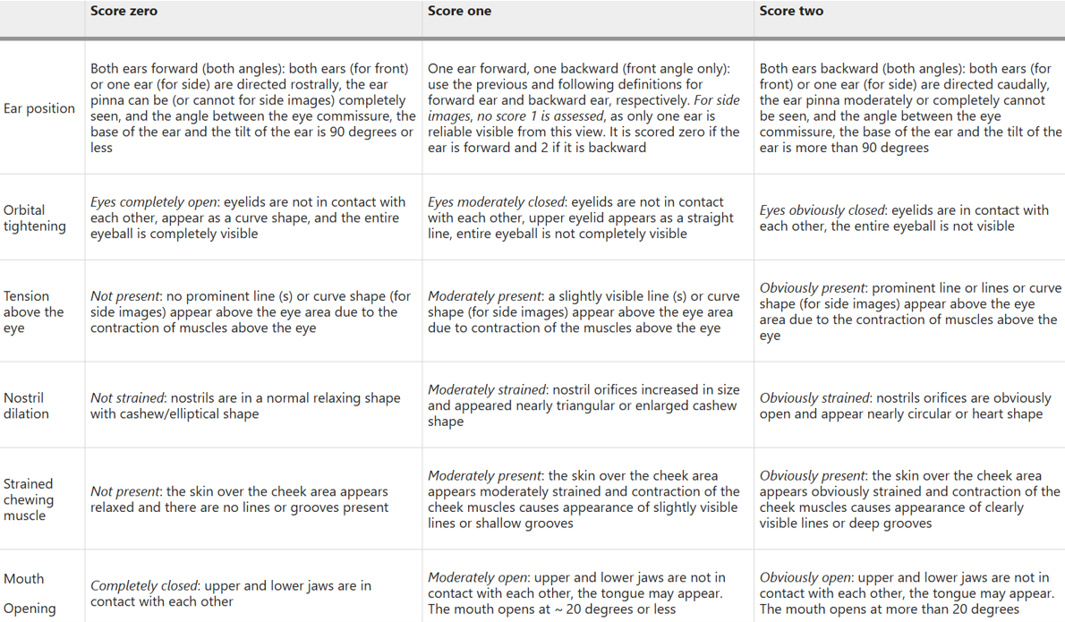
Fig. 1 Dairy Cows Grimace Scale
In recent years, many scholars have proposed various computer vision-based methods for facial recognition and image segmentation of livestock. Ma et al.(R. Ma et al., 2025)developed a pig face detection system named PigFRIS based on YOLOV11 and GAN, achieving precise pig face recognition. Nie et al.(Nie et al., 2024)proposed a pig face detection algorithm using YOLOV5, enhancing the algorithm’s ability to process image details by introducing the CReToNeXt module, which enables accurate judgment of pig expressions. Ma et al. (X. Ma et al., 2022) adopted CSPDarknet53 as the backbone network to develop a chicken face object detection model based on YOLOV4. Weng et al. (Weng et al., 2022)proposed an improved deep residual network called Res5-2Net for recognizing dairy cow faces. Feng et al. (Feng et al., 2025)introduced an enhanced U-Net framework, integrating the Fusion-Augmented Channel Attention and Adaptive Multi-Scale Attention Gate modules to achieve semantic segmentation of dairy cow faces.
Semantic segmentation is a common computer vision algorithm. Since the proposal of Fully Convolutional Networks (FCN) (Long et al., 2015)semantic segmentation algorithms have continuously evolved, driving advancements in applications across multiple fields, including medical imaging. The DeeplabV3+ algorithm, a popular semantic segmentation method in recent years, was introduced in 2018(Chen et al., 2018), as the most advanced version of the Deeplab series. It applies Depthwise Separable Convolution to both the Atrous Spatial Pyramid Pooling (ASPP) module and the decoder module, improving model efficiency. The Efficient Channel Attention (ECA) module is an effective and lightweight attention mechanism. Wang et al.(Wang et al., 2020)argued that dimensionality reduction disrupts the direct correspondence between channels and their weights. To address this, the ECA channel attention mechanism introduces a local cross-channel interaction strategy and 1D convolution to maintain the correspondence between channels and their weights, enhancing the reliability of channel weight assignment. The Feature Pyramid Network (FPN)(Lin et al., 2017)is a common strategy for multi-scale feature extraction, incorporating both bottom-up and top-down pathways. Semantic segmentation algorithms often integrate FPN to generate multi-scale features, processing information at different scales to achieve more refined segmentation. Single Shot Context (Najibi et al., 2017) removes fully connected layers with massive parameters, enabling lightweight facial detection. Although initially developed for face detection, its lightweight architecture and scale invariance make it promising for other detection tasks. The commonly used SSH modules—SSH Detection and SSH Context—both enhance the feature layers’ capability to reconstruct image details.
- Proposed Method
The Pain-Score method we propose is a novel pain detection approach that combines semantic segmentation with the dairy cow facial pain scale, and its flowchart is shown in Figure 2. The workflow of the Pain-Score method consists of three stages, the Segment Process, the Scoring Process, and the Judge Process.
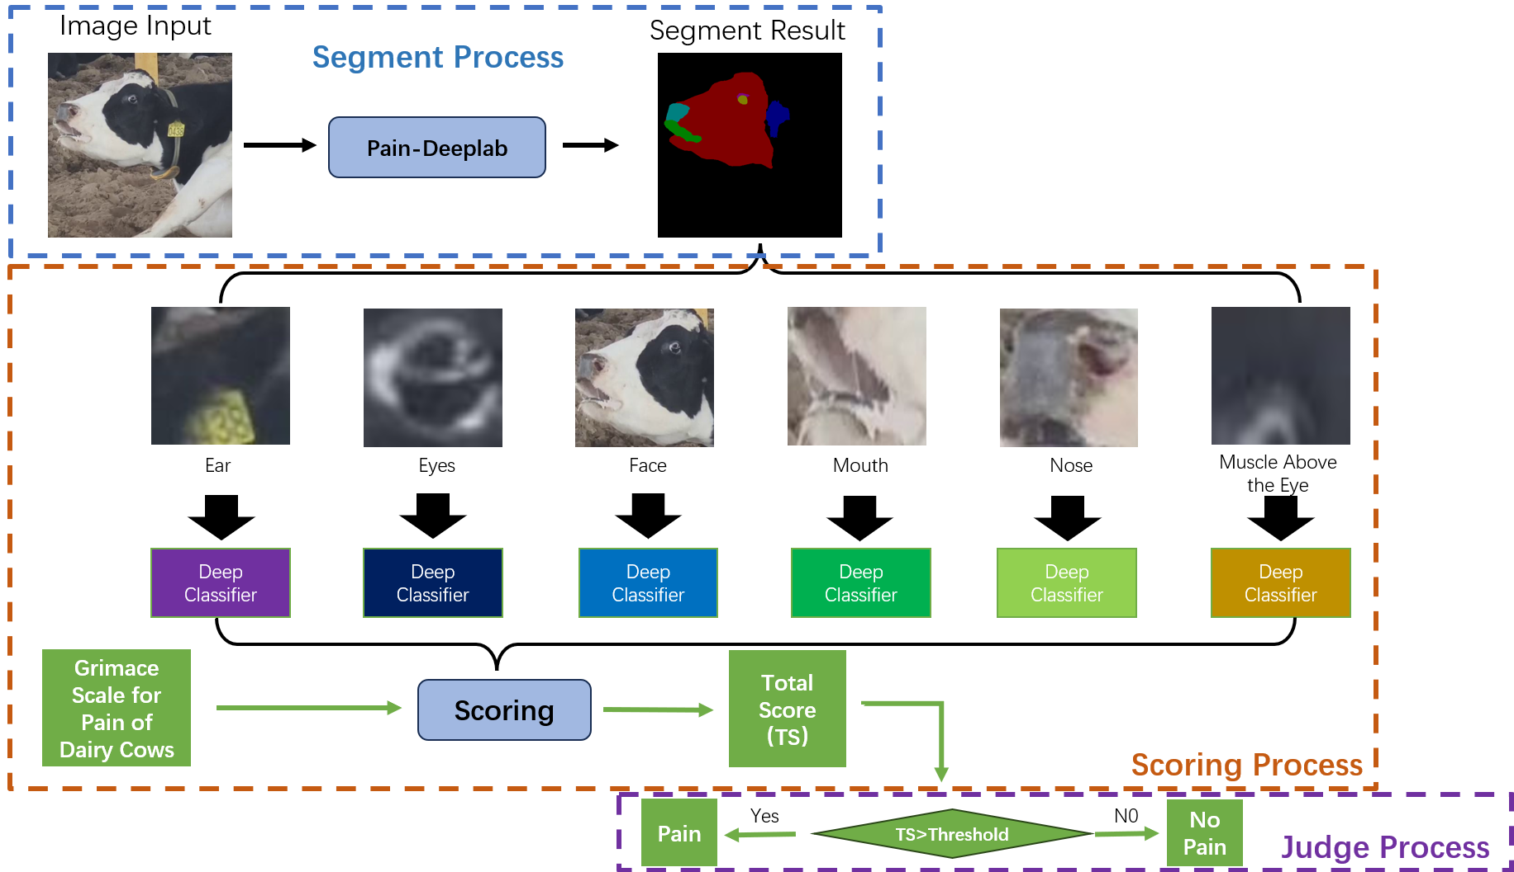
Fig. 2 Pain-Score Steamline
(1) Segment Process: First, the Pain-Deeplab algorithm is used to perform semantic segmentation on the input dairy cow facial images. According to the dairy cow facial pain scale, the dairy cow face is segmented into six parts: ears, eyes, face, mouth, nose, and muscles above the eyes. The score for each part is 0, 1, or 2.
(2) Scoring Process: The six segmented facial parts are then input into six respective deep classifiers for classification and scoring.
(3) Judge Process: Finally, the scores of all facial parts are directly summed to obtain the total score (TS), which represents the overall pain score of the dairy cow. A pain threshold (Threshold) is set according to the dairy cow facial pain scale. When TS > Threshold, the dairy cow is judged to be in a state of pain; otherwise, it is not.

3.1 Image Segmentation in the Face of Dairy Cows
The Pain-Deeplab proposed in this paper addresses the issues of insufficient shallow features and poor feature-based image reconstruction capability in the DeeplabV3+ algorithm, while achieving feature enhancement for the deep features of dairy cow images. The algorithm framework of Pain-Deeplab is shown in Figure 3.
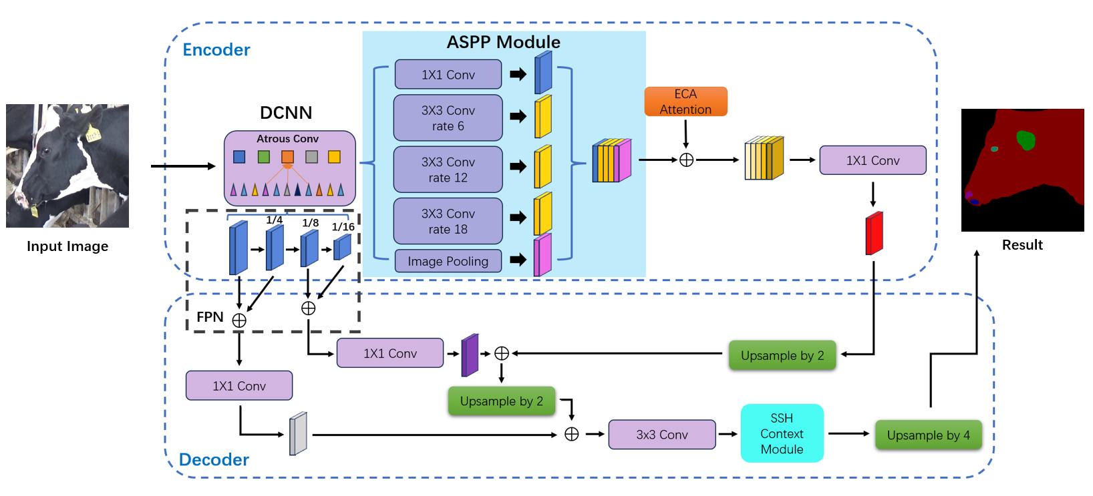
Fig. 3 Pain-Deeplab Framework
(1) Extraction of shallow and deep facial features of dairy cows: First, a dairy cow facial image is input into a deep convolutional neural network (DCNN), commonly referred to as the backbone network, for feature extraction. In the encoder section, the backbone module generates two outputs: shallow facial features (SFF) and deep facial features (DFF) of dairy cows.
(2) Atrous convolution for deep features: The DFF obtained from the backbone undergoes multiple atrous convolutions with different dilation rates (6, 12, and 18). The results of these three atrous convolutions, the result of 1×1 convolution, and the pooling result (totaling five features) are then stacked. This component is also known as the Atrous Spatial Pyramid Pooling (ASPP) module.
(3) Feature enhancement via ECA attention mechanism: This study introduces the ECA mechanism to improve the Pain-Deeplab algorithm’s focus on important facial features of dairy cows. The ECA mechanism assigns weights to each feature from the ASPP module, where higher weights indicate more critical features.
(4) Multi-scale feature fusion of shallow and deep features: In the decoder section, first, multi-scale feature extraction of SFF is performed using the FPN approach, generating three features with sizes of 1/4, 1/8, and 1/16 of the original dairy cow facial image. Next, the two relatively deeper features and the shallowest feature are fused with SFF. After applying 1×1 convolution to the results of these two feature fusions, we obtain the decoder’s deep semantic information (DDSM) and shallow semantic information (DSSM). The feature-enhanced results are then upsampled by a factor of 2 and fused with DDSM, followed by another 2× upsampling and fusion with DSSM. This process enriches the semantic information of shallow features while avoiding errors caused by direct fusion of shallow and deep features(Huang et al., 2025)。
(5) SSH-enhanced feature reconstruction capability: Since deep convolution often leads to significant information loss(Kim et al., 2016), the SSH module is introduced to optimize the reconstruction of dairy cow facial features. The extracted facial feature layers are first processed with a 3×3 convolution and then fed into the SSH module. The output of the SSH module is upsampled by a factor of 4 to generate the final semantic segmentation result of the dairy cow face. The six parts required by the dairy cow facial pain scale are represented by different colors in the segmentation result.
The loss function used in this paper is uniformly the cross-entropy loss function, as shown in Equation (1).
$$\begin{aligned}L\left(y, \hat{y}\right) = -\frac{1}{N} \sum_{i=1}^{N}{\left( y_{i} \log\left(\hat{y_{i}}\right) + \left(1 - y_{i}\right) \log\left(1 - \hat{y_{i}}\right) \right)}\#\left(1\right)\end{aligned}$$
Here, $L$ represents the loss function, $y$ is the ground-truth label, $\hat{y_{i}}$is the predicted value, $N$ is the number of samples, and $y_{i}$ and $\hat{y_{i}}$ denote the ground-truth label and predicted value of the i-th sample, respectively. The following sections will introduce the key modules of Pain-Deeplab one by one.

3.1.1 ECA Attention Feature Refinement Module
This paper utilizes the ECA mechanism to generate feature weights for the output of the ASPP module, enabling the Pain-Deeplab algorithm to focus on more critical facial features of dairy cows. The application of the ECA attention mechanism in Pain-Deeplab is shown in Figure 4.
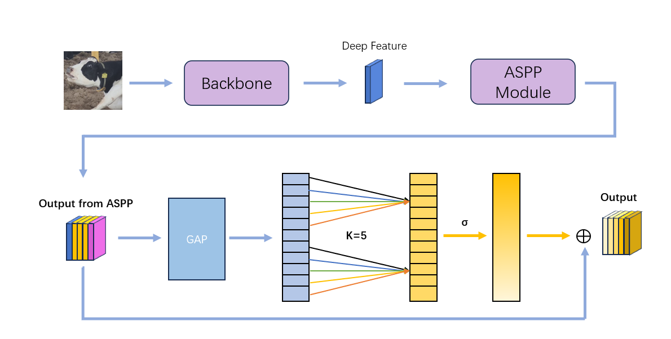
Fig. 4 ECA Attention for Feature Refinement
Here, $K$ denotes the kernel size of the 1D convolution, and $σ$ represents the sigmoid function. First, through the ASPP module, we obtain the stacked facial features of dairy cows. The ECA mechanism first applies global average pooling (GAP) to these features, and the formula for GAP is shown in Equation (2).。
$$\begin{aligned}G\left[c\right]=\frac{1}{H×W}\sum_{i=1}^{H}{\sum_{j=1}^{W}{F\left[i,j,c\right]}}\#\left(2\right)\end{aligned}$$
Here, $H$ represents the height, $W$ denotes the width, $F\left[i,j,c\right]$ is the value of the input feature map at position $\left(i,j\right)$ and channel c, and $G\left[c\right]$ is the c-th element of the output feature vector. Subsequently, the result of GAP is processed using 1D convolution to generate a weight vector. This weight vector is then input into the sigmoid function for normalization to obtain the final weight vector. By combining the output of the ASPP module with this weight vector, the optimized DFF is obtained.

3.1.2 FPN Feature Extraction
This paper introduces the FPN module for multi-scale feature extraction, aiming to enrich the SFF obtained from the Backbone. The application of FPN in Pain-Deeplab is shown in Figure 5.
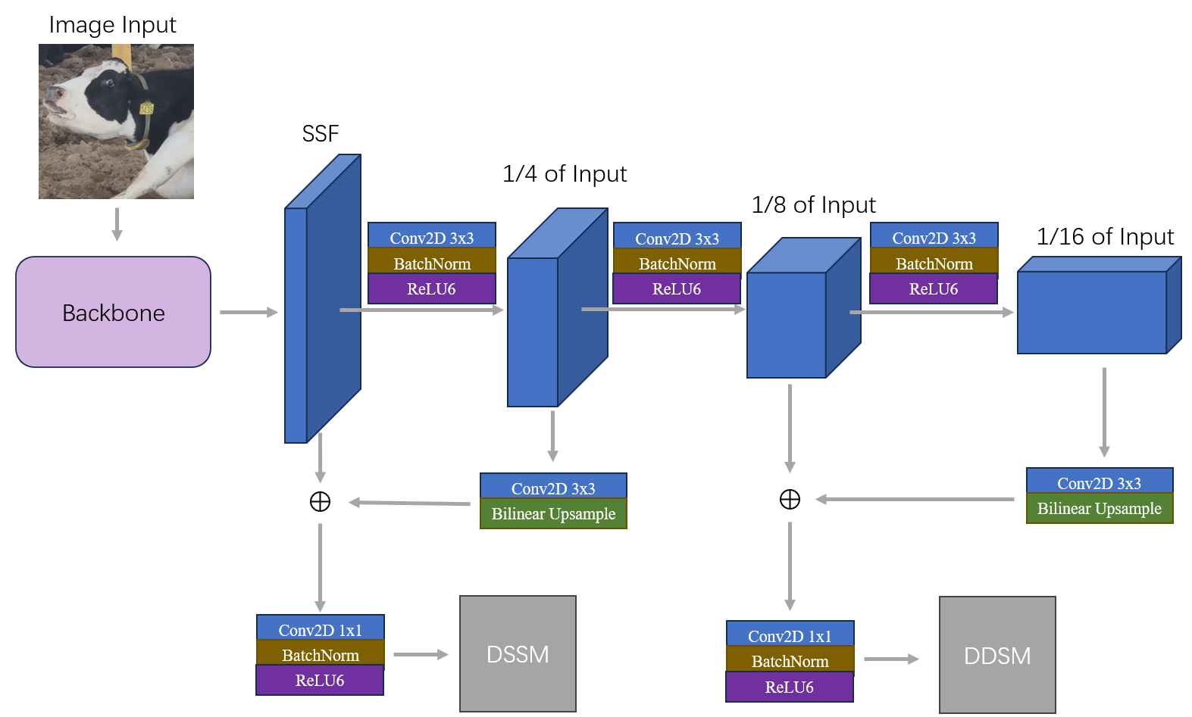
Fig. 5 FPN is used for multi-scale feature extraction.
First, the SFF undergo three convolutional pooling operations with a stride of 2, resulting in three feature layers whose sizes are 1/4, 1/8, and 1/16 of the original image, respectively. Subsequently, the feature layers with sizes 1/4 and 1/16 of the original dairy cow facial image are processed using 3×3 convolutions with a stride of 1. The convolved dairy cow facial feature layers are then upsampled using bilinear interpolation. The formula for bilinear interpolation is shown in Equation (3).。
$$\begin{aligned}Q\left(x,y\right)=\frac{Q_{11}\left(x_{2}-x\right)\left(y_{2}-y\right)+Q_{21}\left(x-x_{1}\right)\left(y_{2}-y\right)+Q_{12}\left(x_{2}-x\right)\left(y-y_{1}\right)+Q_{22}\left(x-x_{1}\right)\left(y-y_{1}\right)}{\left(x_{2}-x_{1}\right)\left(y_{2}-y_{1}\right)}\#\left(3\right)\end{aligned}$$
Where $Q_{11}$ is the value at point $\left(x_{1},y_{1}\right)$,$Q_{21}$is the value at point $\left(x_{2},y_{1}\right)$, $Q_{12}$ is the value at point $\left(x_{1},y_{2}\right)$, and $Q_{22}$ is the value at point $\left(x_{2},y_{2}\right)$. $\left(x_{1},y_{1}\right)$ and $\left(x_{2},y_{2}\right)$are the coordinates of known points. Finally, the upsampled results are respectively stacked with the shallow feature layer and the 1/8-scale feature layer of the original image size. This process ultimately yields DDSM and DSSM respectively.

3.1.3 SSH Context Optimization
This paper selects the SSH Context module to enhance Pain-Deeplab’s capability to reconstruct feature layers of dairy cow facial images into images. The application of SSH in Pain-Deeplab is shown in Figure 6.
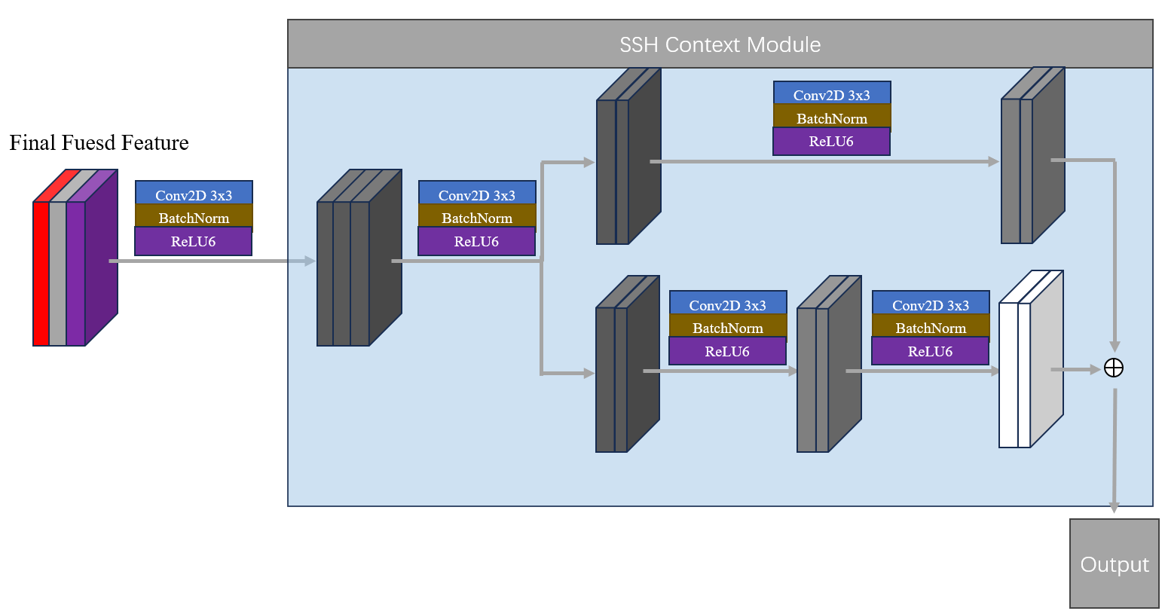
Fig. 6 SSH is used for semantic enhancement in the decoder.
As shown in Figure 3, we first apply a 3×3 convolution with a stride of 1 to the input of the SSH Context module—termed Final Fused Feature—to adjust the number of channels. The resulting feature layer is then split into two parts, each containing half of the original number of channels. The first part undergoes a single 3×3 convolution with a stride of 1, while the second part undergoes two such convolutions. The results of both parts are then stacked to produce the output of the SSH Context module. After upsampling this output by a factor of four, we obtain the semantic segmentation result of the dairy cow face.
  - Facial Scoring of Dairy Cows
After processing dairy cow facial images with Pain-Deeplab, we obtain semantic segmentation results for the six facial regions. The next step is to score these six regions individually. The schematic scoring process is shown in Figure 7.
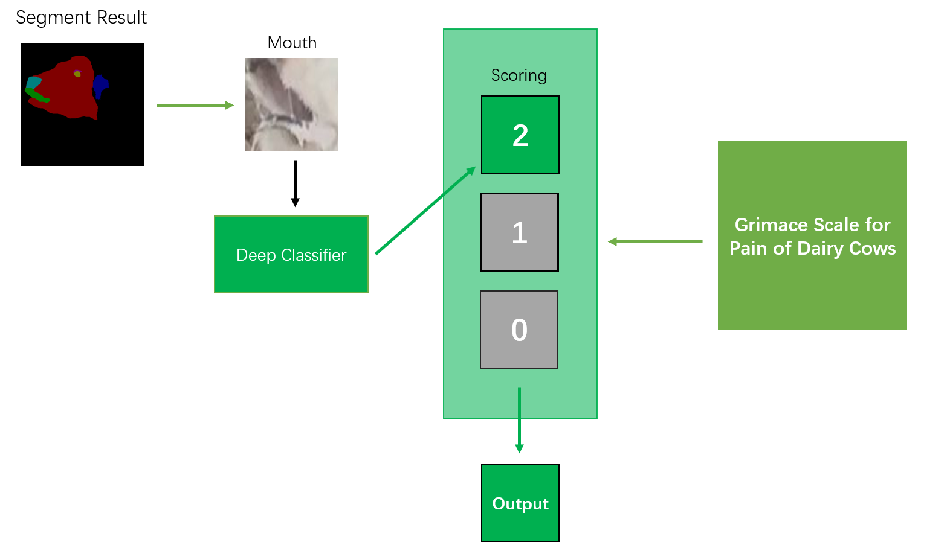
Fig. 7 Scoring Pipeline
As shown in figure 7, we first extract a specific facial region (e.g., Mouth) from the semantic segmentation results. Then, a deep learning classifier scores this region according to the dairy cow facial pain scale. Finally, the same scoring process is applied to the other five facial regions, generating scores for all six parts of the dairy cow’s face.

3.3 Pain Detection of Dairy Cows
In the Judge Process of the Pain-Score method, the scores of the six facial regions are summed up to obtain the overall pain score (TS) of the dairy cow’s face. Referring to the dairy cow behavioral pain scale, a threshold of 5 is set(Gleerup et al., 2017). This paper also adopts a threshold of 5 points. Dairy cows with a total facial pain score greater than 5 are judged to be in a state of pain.
- Experimental Process
All algorithm experiments and training were conducted in the Ubuntu 24.04 Linux operating system environment. The hardware configuration includes 4× i9-14900K CPUs, 8× NVIDIA GeForce RTX 4090 GPUs, and 24 GB RAM. The software environment versions are CUDA 11.8, with the deep learning framework being PyTorch 2.0.1. Pain-Deeplab is trained using the SGD optimizer, with an initial learning rate of 0.007 that is reduced via an exponential decay strategy. The total number of iterations is set to 512, and the batch size is 16. The backbone feature extraction network is MobileNetV2.

4.1 Dataset Introduction
The dataset was collected from December 2024 to January 2025 at Aohua Modern Animal Husbandry Co., Ltd. in Baoji, Shaanxi, and Zhengyuan Ecology Co., Ltd. in Shizuishan, Ningxia. A total of 42 cows at 227 to 272 days of gestation were filmed during parturition, along with 5 cows in a relaxed state. Videos were recorded at a resolution of 1920×1080 pixels using a SONY HRD-PJ675 camera. To reduce data volume, retain key information, and improve processing efficiency, one frame was extracted from each video at 15-frame intervals and saved. A separate folder was created to store the corresponding dairy cow facial images, with low-quality images (blurry or with occluded faces) manually removed. The final dataset comprises 1,525 dairy cow facial images, including 1,466 painful facial images and 59 non-painful facial images. Figure 8 and Figure 9 display examples of dairy cows in painful and non-painful states, respectively.
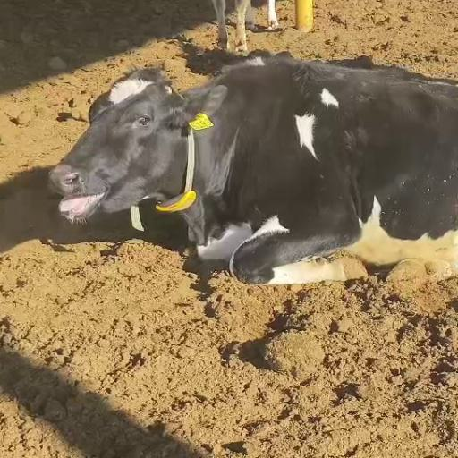  Fig. 8 Dairy cows in a painful state | 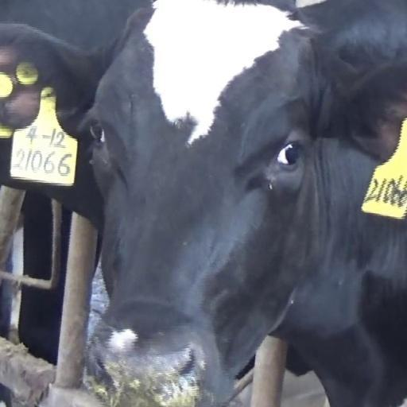  Fig. 9 Dairy cows in a painful state

  - Evaluation Index
This paper uses Mean Intersection over Union (mIOU), Mean Pixel Accuracy (mPA), and Accuracy (ACC) as evaluation metrics for the semantic segmentation algorithm. Intersection over Union (IOU) measures the ratio of the intersection to the union between the prediction and the ground-truth label, while mIOU is the average of IOU values across all categories. Pixel Accuracy (PA) is the proportion of correctly predicted pixels to the total number of pixels, and mPA is the average of PA values for all categories. ACC represents the proportion of correctly predicted pixels to the total pixels. The calculations for mIOU, mPA, and ACC are shown in Equations (4), (5), and (6), respectively.
$$\begin{aligned}\text{mIOU}=\frac{1}{C}\sum_{i=1}^{C}{\frac{{ P}_{i}∩G_{i}}{{ P}_{i}∪G_{i}}}\#\left(4\right)\end{aligned}$$
$$\begin{aligned}\text{mPA}=\frac{1}{C}\sum_{i=1}^{C}{\frac{{ P}_{i}∩G_{i}}{G_{i}}}\#\left(5\right)\end{aligned}$$
$$\begin{aligned}\text{ACC}=\frac{\sum_{i=1}^{C}{P_{i}∩G_{i}}}{\sum_{i=1}^{C}{G_{i}}}\#\left(6\right)\end{aligned}$$
Here, C is the total number of categories, $P_{i}$ is the predicted region for the i-th category, and $G_{i}$ is the ground-truth region for the i-th category.
For evaluating the deep classifiers used in scoring, four metrics are employed: Precision, Recall, F1-Score, and G-mean. Precision is the ratio of true positives (TP) to all positive predictions. Recall is the ratio of TP to all actual positive samples. F1-Score is the harmonic mean of Precision and Recall, while G-mean is the geometric mean of Precision and Recall. Their formulas are given by Equations (7) to (10).
$$\begin{aligned}\text{Precision}=\frac{TP}{TP+FP}\#\left(7\right)\end{aligned}$$
$$\begin{aligned}\text{Recall}=\frac{TP}{TP+FN}\#\left(8\right)\end{aligned}$$
$$\begin{aligned}\text{F1}\text{-Score}=2⋅\frac{\text{Precision}⋅\text{Recall}}{\text{Precision}+\text{Recall}}\#\left(9\right)\end{aligned}$$
$$\begin{aligned}\text{G-mean}=\sqrt{\text{Recall}⋅\text{Precision}}\#\left(10\right)\end{aligned}$$
In these equations, TP denotes true positives, FP denotes false positives, and FN denotes false negatives.
  - Experimental Design
In Section 4.4.1, we first conducted ablation experiments to verify the performance improvement of DeeplabV3+ by incorporating three modules: ECA Attention, FPN, and SSH. Subsequently, in Section 4.4.2, we selected four common semantic segmentation algorithms (Unet, PSPnet, FCN, and Ir-ASPP) for performance comparison with Pain-Deeplab, aiming to evaluate the performance of Pain-Deeplab. Through semantic segmentation, we obtained the six facial regions of dairy cows. In Section 4.4.3, we performed classification on each facial region using nine classifiers (VGG-16, Alexnet, Googlenet, ResNet-18, Densenet, EfficientnetV2, Swin-transformer, and MobileViT), and selected the classifier with the best performance for scoring that region. The scores of all regions were then summed, and a threshold of 5 was used to determine whether the dairy cow was in a state of pain. The results of the Pain-Score method are presented in Section 4.4.4. In Section 4.4.5, we used nine classifiers for pain detection in dairy cows and compared their results with those of Pain-Score, aiming to discuss the performance differences between pure deep learning methods and the proposed approach that combines deep learning with subjective methods for dairy cow pain detection.

4.4 Experimental Results

4.4.1 Ablation Experiment
To verify the performance improvement of the DeeplabV3+ model by the ECA Attention, FPN, and SSH modules, we conducted ablation experiments. We compared the results of DeeplabV3+ incorporating 1 module, 2 modules, and all 3 modules, respectively. The experimental results are shown in Table 1.
Table 1 Ablation Experiment Result
DeeplabV3+ | ECA Attention | FPN | SSH | mIOU | mPA | ACC
√ |  |  |  | 0.5554 | 0.6418 | 0.9760
√ | √ |  |  | 0.6045 | 0.7434 | 0.9771
√ |  | √ |  | 0.6079 | 0.7576 | 0.9721
√ |  |  | √ | 0.6162 | 0.7483 | 0.9731
√ | √ | √ |  | 0.6388 | 0.7755 | 0.9741
√ | √ |  | √ | 0.6394 | 0.7721 | 0.9723
√ |  | √ | √ | 0.6407 | 0.7673 | 0.9739
√ | √ | √ | √ | 0.6684 | 0.7797 | 0.9793
Where “√” indicates the inclusion of the module, and a blank indicates exclusion. The experimental results show that Pain-Deeplab incorporating the ECA Attention, FPN, and SSH modules achieves the best performance, with the highest mIOU, mPA, and ACC values. It also demonstrates a significant improvement compared to the baseline DeeplabV3.

4.4.2 Comparison of Dairy Cows Facial Image Segmentation Algorithms
To evaluate the performance of Pain-Deeplab, we conducted a performance comparison between Pain-Deeplab and four common semantic segmentation algorithms on our dairy cow pain dataset. The comparison results are shown in Table 2.
Table 2 Comparison of Dairy Cows Facial Image Segmentation Algorithms
Algorithm | mIOU | mPA | ACC
Unet | 0.6370 | 0.7247 | 0.9752
PSPnet | 0.4318 | 0.5035 | 0.9634
FCN | 0.5730 | 0.7759 | 0.9770
Ir-Aspp | 0.3570 | 0.5688 | 0.9542
Pain-deeplab | 0.6684 | 0.7797 | 0.9793
It can be seen that Pain-Deeplab has the best performance, achieving the highest mIOU, mPA, and ACC.

4.4.3 Comparison of Dairy Cows Facial Scoring Algorithms
To select the optimal scoring classifier for each dairy cow facial region obtained, we compared the performance of 8 classifiers across 6 facial regions. The performance of the 8 classifiers on each facial region is shown in Tables 3 to 9.
Table 3 Performance comparison of scoring classifiers on the ear.
Algorithm | F1-Score | Recall | G-mean | Precision
VGG-16 | 0.5801 | 0.5200 | 0.5604 | 0.6511
Alexnet | 0.7567 | 0.7391 | 0.7483 | 0.7762
Googlenet | 0.8451 | 0.9169 | 0.8482 | 0.7843
ResNet-18 | 0.8059 | 0.8611 | 0.8068 | 0.7570
Densenet | 0.9585 | 0.9589 | 0.9597 | 0.9605
EfficientnetV2 | 0.9139 | 0.8765 | 0.9110 | 0.9160
Swin_transformer | 0.8899 | 0.9247 | 0.9294 | 0.9270
MobileViT | 0.9655 | 0.9658 | 0.9660 | 0.9662

Table 4 Performance comparison of scoring classifiers on the mouth.
Algorithm | F1-Score | Recall | G-mean | Precision
VGG-16 | 0.3952 | 0.5541 | 0.4119 | 0.3070
Alexnet | 0.7762 | 0.7860 | 0.7760 | 0.7661
Googlenet | 0.4630 | 0.3959 | 0.4700 | 0.5591
ResNet-18 | 0.7580 | 0.8100 | 0.7602 | 0.7131
Densenet | 0.8913 | 0.8902 | 0.8931 | 0.8960
EfficientnetV2 | 0.8518 | 0.8485 | 0.8573 | 0.8661
Swin_transformer | 0.9019 | 0.9015 | 0.9029 | 0.9042
MobileViT | 0.8975 | 0.8977 | 0.8991 | 0.9005

Table 5Performance comparison of scoring classifiers on the eyes.
Algorithm | F1-Score | Recall | G-mean | Precision
VGG-16 | 0.4772 | 0.3867 | 0.6221 | 0.4910
Alexnet | 0.8462 | 0.9711 | 0.8533 | 0.7501
Googlenet | 0.5299 | 0.8753 | 0.5768 | 0.3802
ResNet-18 | 0.5544 | 0.8709 | 0.5874 | 0.3962
Densenet | 0.9320 | 0.9310 | 0.9329 | 0.9348
EfficientnetV2 | 0.8507 | 0.8517 | 0.8520 | 0.8523
Swin_transformer | 0.9350 | 0.9345 | 0.9354 | 0.9363
MobileViT | 0.8916 | 0.8897 | 0.8933 | 0.8971

Table 6 Performance comparison of scoring classifiers on the nose.
Algorithm | F1-Score | Recall | G-mean | Precision
VGG-16 | 0.6700 | 0.7700 | 0.6762 | 0.5931
Alexnet | 0.6669 | 0.5560 | 0.6800 | 0.8333
Googlenet | 0.9371 | 0.8820 | 0.9391 | 1
ResNet-18 | 0.3822 | 0.7080 | 0.4301 | 0.2611
Densenet | 0 9624 | 0.9622 | 0.9628 | 0.9634
EfficientnetV2 | 0.9278 | 0.9244 | 0.9312 | 0.9381
Swin_transformer | 0.9722 | 0.9725 | 0.9725 | 0.9725
MobileViT | 0.8735 | 0.8902 | 0.8943 | 0.8852

Table 7 Performance comparison of scoring classifiers on the muscle above the eye.
Algorithm | F1-Score | Recall | G-mean | Precision
VGG-16 | 0.5971 | 0.6461 | 0.6760 | 0.7059
Alexnet | 0.6270 | 0.4954 | 0.6501 | 0.8522
Googlenet | 0.6542 | 0.6202 | 0.6389 | 0.6811
ResNet-18 | 0.6541 | 0.5210 | 0.6761 | 0.8770
Densenet | 0.8300 | 0.8386 | 0.8385 | 0.8385
EfficientnetV2 | 0.7990 | 0.8000 | 0.7996 | 0.7991
Swin_transformer | 0.8560 | 0.8596 | 0.8568 | 0.8540
MobileViT | 0.8536 | 0.8561 | 0.8542 | 0.8522

Table 8 Performance comparison of scoring classifiers on the face.
Algorithm | F1-Score | Recall | G-mean | Precision
VGG-16 | 0.1632 | 0.3303 | 0.1891 | 0.1091
Alexnet | 0.5221 | 0.3751 | 0.5672 | 0.8573
Googlenet | 0.7451 | 0.7002 | 0.7461 | 0.7952
ResNet-18 | 0.8522 | 0.7674 | 0.8573 | 0.9583
Densenet | 0.9896 | 0.9897 | 0.9899 | 0.9896
EfficientnetV2 | 0.9758 | 0.9759 | 0.9759 | 0.9759
Swin_transformer | 0.9897 | 0.9898 | 0.9897 | 0.9897
MobileViT | 0.9827 | 0.9828 | 0.9828 | 0.9828
The experimental results show that the classification algorithm that performed best in scoring the ears of dairy cows was MobileViT. Swin-transformer was the top-performing classification algorithm for the remaining five facial regions. Therefore, this paper selects MobileViT as the classification algorithm for scoring dairy cow ears, and Swin-transformer as the classification algorithm for scoring the eyes, nose, mouth, muscles above the eyes, and facial muscles.

4.4.4 Dairy Cow Pain Detection Using Pain-Score
After obtaining the scores for all facial regions, we sum them up to obtain the total score and use a threshold of 5 points to distinguish whether the dairy cow is in pain, thereby deriving the experimental results of the Pain-Score method for dairy cow pain detection. The dataset is divided into a training set and a test set at a 7:3 ratio. The performance of Pain-Score in dairy cow pain detection is shown in Table 9.。
Table 9 The performance of Pain-Score in detecting dairy cow pain.
DateSet | F1-Score | Recall | G-mean | Precision
Totally | 0.9252 | 0.9125 | 0.8996 | 0.9526
Test Set | 0.9408 | 0.9318 | 0.9173 | 0.9599
Train Set | 0.9474 | 0.9062 | 0.9122 | 0.9923

4.4.5 Comparison of Pain-Score Method with Traditional Deep Learning Methods for Dairy Cow Pain Detection Results

In order to discuss the performance differences between common deep learning methods and the proposed approach that combines deep learning with subjective methods for dairy cow pain detection, we compared the experimental results of Pain-Score with the pain detection results of the 8 deep classifiers in Section 4.4.3 on the dairy cow pain dataset. The comparison results are shown in Table 10.
Table 10 Comparison of Pain-Score with other deep learning methods
Algorithm | F1-Score | Recall | G-mean | Precision
VGG-16 | 0.8752 | 0.9160 | 0.8758 | 0.8389
Alexnet | 0.9880 | 0.9933 | 0.9880 | 0.9831
Googlenet | 0.9244 | 0.8381 | 0.8670 | 0.8800
ResNet-18 | 0.9631 | 0.9401 | 0.9631 | 0.9990
Densenet | 0.9936 | 0.9937 | 0.9937 | 0.9937
EfficientnetV2 | 0.9849 | 0.9842 | 0.9856 | 0.9869
Swin_transformer | 0.9820 | 0.9811 | 0.9830 | 0.9849
MobileViT | 0.8879 | 0.9243 | 0.8886 | 0.8543
Pain-score | 0.9408 | 0.9318 | 0.9173 | 0.9599
The experimental results show that our proposed Pain-Score method ranked sixth, outperforming three deep classifiers: VGG-16, MobileViT, and Googlenet. Although its performance did not reach the top level compared with common deep learning-based pain detection methods, the Pain-Score method still demonstrated good performance in dairy cow pain detection. Specifically, its F1-Score, Recall, G-mean, and Precision were 0.0582, 0.0619, 0.0764, and 0.0391 lower than the highest results, respectively. Additionally, the Pain-Score method can be combined with veterinarians’ expertise—veterinarians can fine-tune it based on their experience, such as modifying the weights of different facial regions, adjusting the pain threshold, or even revising the pain score of a specific region. This adaptability makes the Pain-Score method more practical and applicable in real-world scenarios.
- Discussion
The experimental results show that the Pain-Deeplab algorithm performs well in the semantic segmentation task of dairy cow faces. On our dairy cow pain dataset, Pain-Deeplab achieved the best performance, with mIOU, mPA, and ACC reaching 0.6684, 0.7797, and 0.9793, respectively. Results from the ablation experiments also indicate that the three modules added to Pain-Deeplab (ECA, FPN, and SSH) all contribute to improving its performance. The ECA attention mechanism enables Pain-Deeplab to focus on more important facial features of dairy cows while suppressing irrelevant ones, helping the algorithm prioritize facial regions over background noise. The FPN module enriches shallow features and realizes multi-scale feature fusion between shallow and deep facial features, expanding the range of learnable facial features and enhancing the algorithm’s robustness. The SSH module improves Pain-Deeplab’s ability to restore facial feature layers into semantic segmentation results, thereby enhancing the accuracy of facial segmentation.
Although Pain-Score was not the top-performing method for dairy cow pain detection—ranking 6th among the 9 methods in Table 10. its F1-Score, Recall, G-mean, and Precision (0.9408, 0.9318, 0.9173, and 0.9599, respectively) still demonstrate good performance, slightly lower than the best-performing Densenet algorithm. The primary reason for its suboptimal ranking is likely the error accumulation from using deep learning in both the semantic segmentation and pain scoring stages. Nevertheless, Pain-Score holds practical significance for several reasons. First, it achieves reliable pain detection in most cases, as evidenced by its strong scores on our dataset. Second, it offers controllability: veterinarians can influence the final results by adjusting the pain threshold, modifying the weights of different facial regions, or even revising the pain score of a specific area. Since different cow breeds, environmental conditions, and individual cows may exhibit varying pain responses, a deep learning model trained on a single dataset cannot universally apply to all herds. In veterinary medicine, where minor errors can have severe consequences, integrating veterinarians’ long-term field experience with Pain-Score’s detection results is more practical than relying solely on deep learning algorithms.
However, our dataset may be insufficient. In the future, we will continuously collect pain data from dairy cows in other scenarios (e.g., mastitis, lameness) to enrich our dataset. Further research on Pain-Score will focus on practical applications. An ideal scenario involves installing cameras in barns to capture clear facial images, processing real-time footage with Pain-Score in the background, and transmitting real-time cow IDs and facial region scores to veterinarians’ portable devices. When the total pain score exceeds the threshold for an extended period, an alert is triggered. Although specific implementation details are still lacking, the application of Pain-Score represents a promising direction.
- Conclusion
Accurate pain detection is a critical issue in the field of animal welfare. Traditional subjective methods for detecting pain in dairy cows rely heavily on veterinarians’ expertise and require significant effort from them. To address these challenges, we propose the Pain-Score method, a novel approach that combines computer vision algorithms with subjective pain detection methods for dairy cows. It first uses the Pain-Deeplab algorithm to achieve precise segmentation of dairy cow faces, then employs scoring classifiers corresponding to a dairy cow pain scale to score each facial region individually, and finally determines whether the cow is in pain based on the total score. The Pain-Score method enables fine-grained facial segmentation and accurate regional scoring, ultimately achieving precise pain detection in dairy cows.
Experimental results demonstrate that the Pain-Score method exhibits excellent performance in dairy cow pain detection, with an F1-Score of 0.9408, Recall of 0.9318, G-mean of 0.9173, and Precision of 0.9599. By innovatively integrating subjective pain assessment methods with computer vision algorithms, Pain-Score achieves accurate pain detection. Its most significant advantages and characteristics lie in controllability and practicality. In real-world applications, veterinarians can fine-tune the Pain-Score method using their clinical experience, enabling it to achieve precise pain detection in more specific scenarios.
Looking ahead, we will focus on researching the practical implementation of the Pain-Score method, aiming to develop a feasible solution for real-time dairy cow pain monitoring that integrates barn surveillance with the Pain-Score framework. This will contribute to new advancements in agricultural intelligence and precision livestock management.
References
Barrier, A. C., Haskell, M. J., Macrae, A. I., & Dwyer, C. M. (2012). Parturition progress and behaviours in dairy cows with calving difficulty. Applied Animal Behaviour Science, 139(3), 209–217. https://doi.org/10.1016/j.applanim.2012.03.003
Chen, L.-C., Zhu, Y., Papandreou, G., Schroff, F., & Adam, H. (2018). Encoder-Decoder with Atrous Separable Convolution for Semantic Image Segmentation (arXiv:1802.02611). arXiv. https://doi.org/10.48550/arXiv.1802.02611
Farghal, M., Pajor, E., Luna, S. P. L., Pang, D., Windeyer, M. C., & Ceballos, M. C. (2024). Development of the calf grimace scale for pain and stress assessment in castrated Angus beef calves. Scientific Reports, 14(1), 25620. https://doi.org/10.1038/s41598-024-77147-6
Feng, X., Zhang, J., Qi, Y., Liu, L., & Li, Y. (2025). DBCA-Net: A Dual-Branch Context-Aware Algorithm for Cattle Face Segmentation and Recognition. Agriculture, 15(5), Article 5. https://doi.org/10.3390/agriculture15050516
Gleerup, K. B., Andersen, P. H., Munksgaard, L., & Forkman, B. (2015). Pain evaluation in dairy cattle. Applied Animal Behaviour Science, 171, 25–32. https://doi.org/10.1016/j.applanim.2015.08.023
Gleerup, K. B., Forkman, B., Otten, N. D., Munksgaard, L., & Andersen, P. H. (2017). Identifying pain behaviours in dairy cattle. WCDS Adv Dairy Technol, 29, 231–239.
Higaki, S., Menezes, G. L., Ferreira, R. E. P., Negreiro, A., Cabrera, V. E., & Dórea, J. R. R. (2024). Objective dairy cow mobility analysis and scoring system using computer vision-based keypoint detection technique from top-view 2D videos. Journal of Dairy Science. https://doi.org/10.3168/jds.2024-25545
Huang, Y., Zhang, K., Liu, W., Wang, Y., Patel, V. M., Lu, L., Han, X., Jin, D., & Yan, K. (2025). HarmonySeg: Tubular Structure Segmentation with Deep-Shallow Feature Fusion and Growth-Suppression Balanced Loss (arXiv:2504.07827). arXiv. https://doi.org/10.48550/arXiv.2504.07827
Huxley, J. N., & Whay, H. R. (2006). Current attitudes of cattle practitioners to pain and the use of analgesics in cattle. Veterinary Record, 159(20), 662–668. https://doi.org/10.1136/vr.159.20.662
Kielland, C., Ruud, L. E., Zanella, A. J., & Østerås, O. (2009). Prevalence and risk factors for skin lesions on legs of dairy cattle housed in freestalls in Norway. Journal of Dairy Science, 92(11), 5487–5496. https://doi.org/10.3168/jds.2009-2293
Kielland, C., Skjerve, E., & Zanella, A. J. (2009). Attitudes of veterinary students to pain in cattle. Veterinary Record, 165(9), 254–258. https://doi.org/10.1136/vr.165.9.254
Kim, J., Lee, J. K., & Lee, K. M. (2016). Accurate Image Super-Resolution Using Very Deep Convolutional Networks. 2016 IEEE Conference on Computer Vision and Pattern Recognition (CVPR), 1646–1654. https://doi.org/10.1109/CVPR.2016.182
Lin, T.-Y., Dollar, P., Girshick, R., He, K., Hariharan, B., & Belongie, S. (2017). Feature Pyramid Networks for Object Detection. 2017 IEEE Conference on Computer Vision and Pattern Recognition (CVPR), 936–944. https://doi.org/10.1109/CVPR.2017.106
Long, J., Shelhamer, E., & Darrell, T. (2015). Fully Convolutional Networks for Semantic Segmentation.
Ma, R., Chung, S., Kim, S., & Kim, H. (2025). PigFRIS: A Three-Stage Pipeline for Fence Occlusion Segmentation, GAN-Based Pig Face Inpainting, and Efficient Pig Face Recognition. Animals, 15(7), Article 7. https://doi.org/10.3390/ani15070978
Ma, X., Lu, X., Huang, Y., Yang, X., Xu, Z., Mo, G., Ren, Y., & Li, L. (2022). An Advanced Chicken Face Detection Network Based on GAN and MAE. Animals, 12(21), Article 21. https://doi.org/10.3390/ani12213055
MERSKEY, H. (1979). Pain terms: A list with definitions and notes on usage. recommended by the IASP subcommittee on taxonomy. Pain, 6, 249–252. https://cir.nii.ac.jp/crid/1572543024166034688
Najibi, M., Samangouei, P., Chellappa, R., & Davis, L. S. (2017). SSH: Single Stage Headless Face Detector. 2017 IEEE International Conference on Computer Vision (ICCV), 4885–4894. https://doi.org/10.1109/ICCV.2017.522
Nie, L., Li, B., Du, Y., Jiao, F., Song, X., & Liu, Z. (2024). Deep learning strategies with CReToNeXt-YOLOv5 for advanced pig face emotion detection. Scientific Reports, 14(1), 1679. https://doi.org/10.1038/s41598-024-51755-8
O’Callaghan, K. A., Cripps, P. J., Downham, D. Y., & Murray, R. D. (2003). Subjective and Objective Assessment of Pain and Discomfort Due to Lameness in Dairy Cattle. Animal Welfare, 12(4), 605–610. https://doi.org/10.1017/S0962728600026257
Peters, M. D. P., Silveira, I. D. B., & Fischer, V. (2015). Impact of subclinical and clinical mastitis on sensitivity to pain of dairy cows. Animal, 9(12), 2024–2028. https://doi.org/10.1017/S1751731115001391
Roche, S., Saraceni, J., Zehr, L., & Renaud, D. (2025). Pain in Dairy Cattle: A Narrative Review of the Need for Pain Control, Industry Practices and Stakeholder Expectations, and Opportunities. Animals, 15(6), Article 6. https://doi.org/10.3390/ani15060877
Tschoner, T. (2021). Methods for Pain Assessment in Calves and Their Use for the Evaluation of Pain during Different Procedures—A Review. Animals, 11(5), Article 5. https://doi.org/10.3390/ani11051235
Tschoner, T., Mueller, K. R., Zablotski, Y., & Feist, M. (2024). Pain Assessment in Cattle by Use of Numerical Rating and Visual Analogue Scales—A Systematic Review and Meta-Analysis. Animals : An Open Access Journal from MDPI, 14(2), 351. https://doi.org/10.3390/ani14020351
Urban-Chmiel, R., Mudroň, P., Abramowicz, B., Kurek, Ł., & Stachura, R. (2024). Lameness in Cattle—Etiopathogenesis, Prevention and Treatment. Animals : An Open Access Journal from MDPI, 14(12), 1836. https://doi.org/10.3390/ani14121836
Wang, Q., Wu, B., Zhu, P., Li, P., Zuo, W., & Hu, Q. (2020). ECA-Net: Efficient Channel Attention for Deep Convolutional Neural Networks. 2020 IEEE/CVF Conference on Computer Vision and Pattern Recognition (CVPR), 11531–11539. https://doi.org/10.1109/CVPR42600.2020.01155
Weng, Z., Fan, L., Zhang, Y., Zheng, Z., Gong, C., & Wei, Z. (2022). Facial Recognition of Dairy Cattle Based on Improved Convolutional Neural Network. IEICE Transactions on Information and Systems, E105.D(6), 1234–1238. https://doi.org/10.1587/transinf.2022EDP7008
Zoltick, A. H., Mann, S., & Coetzee, J. F. (2024). Pain pathophysiology and pharmacology of cattle: How improved understanding can enhance pain prevention, mitigation, and welfare. Frontiers in Pain Research, 5, 1396992. https://doi.org/10.3389/fpain.2024.1396992

